Teacher Professional Development
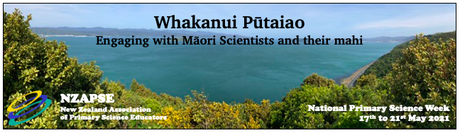
(Hutt Science in association with Capital City Science Educators)
Karakia Ko Te Pū:
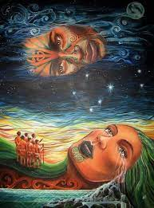
ko te pū  te more  te weu  te aka  te rea  Ko te waonui  te kune  te whē  te Kore  te pō  Ki ngā tāngata Māori  Nā Rangi rāua ko Papa  Ko tēnei te tīmatanga o te ao (x2) | It is the kernal  the taproot  the fibrous roots  the shoot  the offshoots  It is the canopy  the buds  the rustling of the leaves  the void of potential  the night  For Māori  Due to Rangi and Papa  We have the beginnings of life on earth
Kawakawa & Lavender Balm Recipe
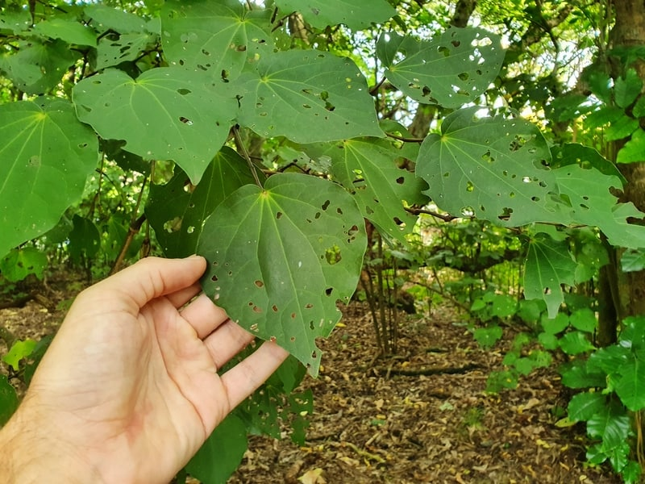
This nourishing Kawakawa infused balm comes in handy for basically everything. Keep it on hand to soothe cuts, scrapes and burns, also comes in handy for itchy skin or pesky bee stings.
Ingredients:
1 cup olive oil or coconut oil
10 Kawakawa leaves*
3 tbsp grated beeswax
10 drops lavender essential oil
1. Place the kawakawa leaves in a thermos. Gently heat the olive oil in a saucepan over medium heat for about one minute. You want the oil to be almost steaming, not overly hot.
2. Pour the oil over the leaves, and then screw the top on your thermos. Infuse for at least 8 hours. Once cool, you can remove the kawakawa leaves. ***** Ensure you put the used leaves back in the bush
3. Combine the infused oil and beeswax together over a double boiler. Stir until melted together and then stir in the essential oils.
4. Pour the mixture into tins or small jars, and allow to set, about 20 minutes. Makes about 4 small jars.

*Kawakawa is native to New Zealand, and is known to have wonderful healing qualities.
Karakia Rongoā
(karakia from Whaea Viv Body, used before the making of rongoā.)
Tāne te maramatanga
Tāne te pūkenga
Tāne te hinengaro
Whakarongo mai, whakarongo mai
I tohia koe e Io, te urutapu o rongo
Nau I tiki ngā kete e toru o te wānanga
Nau I whakamana te tangata
Whakamārama mai, whakamārama mai
Nau I poupou te marama te po
Ko koe te hā o te ora
Ko koe te āhua o te tangata
Ko koe, ko au
Ko au, ko koe
Haumie! Hui e! Taiki e!

Useful Links
https://www.landcareresearch.co.nz/publications/te-reo-o-te-repo/ this is a downloadable book on wetlands from a Maori perspective.
https://www.taupofortomorrow.co.nz/worksheets-factsheets

Connected Series – Mātauranga Māori Links:
Connected | Article | Science links
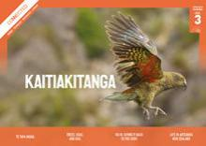  2020  Level 3 | Te Tapa Ingoa | How early Māori went about naming and grouping the plants and animals  Matauranga  Comparisons with the Linnaean system for naming and grouping organisms
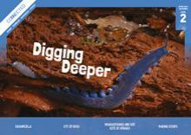  2020  Level 2 | Whakaotirangi and her Kete of Kūmara | Traditional techniques for planting and storing  Matauranga
2018  Level 3 | Listening to the land | Mātauranga Māori  Maramataka - the Maori Calendar  Seasons  Caring for the land  Climate change  Scientists in the field
2015  Level 3 | The Science of Rongoa | Rongoa - Maori Medicine  Kawakawa  Critiquing evidence
2015  Level 2 | Learning from the Tangata Whenua | Sustainability  Te Pūtaiao Māori  Conservation
2014  Level 4 | Black is Back | Materials fibres  Maori fabrics  Piupiu, Harekeke (flax) dyeing  Acid / Alkaline  Chemistry
Level 4  2013 | After the Spill  (Rena Oil Spill)  Audio narration | Pollution  Oil  Mātauranga Māori  Marine environment  Filter feeding  Food webs  Oil Spill teaching resource
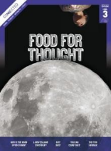  2013  Level 3 | Why is the Moon upside down?  Audio narration available | Gather and interpret data  Questioning  Observations  The Moon- viewed from Southern and Northern hemispheres  Phases of the Moon  Investigations  Teacher Support material  Rona and the Moon  Maramataka, or Māori lunar calendar

